Server Dashboard

on WIN16DBRIL\MES at 9/21/2021 7:53:48 PM

  This report provides overview data about the SQL Server instance, its configuration, and activity on it.
  Configuration Details:
Server Startup Time | Sep 21 2021 5:09PM |  | Server Collation | SQL_Latin1_General_CP1_CI_AS
Server Instance Name | WIN16DBRIL\MES |  | Is Clustered | No
Product Version | 13.0.5264.1 |  | Is FullText Installed | Yes
Edition | Enterprise Edition (64-bit) |  | Is Integrated Security Only | No
Scheduled Agent Jobs | 25 |  | # Processors (used by instance) | 20

  Non Default Configuration Options:
  Activity Details:
  Active Sessions | 12
  Active Transactions | 146
  Active Databases | 22
  Total Server Memory (KB) | 22512464
  Idle Sessions | 508
  Blocked Transactions | 0
  Distinct Connected Logins on Sessions | 4
  Traces Running | 1
 |  |  | 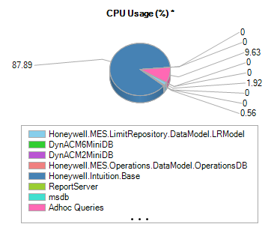 |  |  | 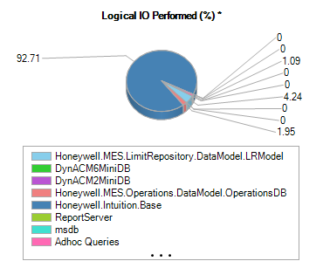
  * : "CPU Usage" and "IO Performed" charts show the cumulative share of all objects by databases.

